Pocket Disk & SSD Disk Enclosure
2.5" USB3.1 SATA Disk & SSD Transfers
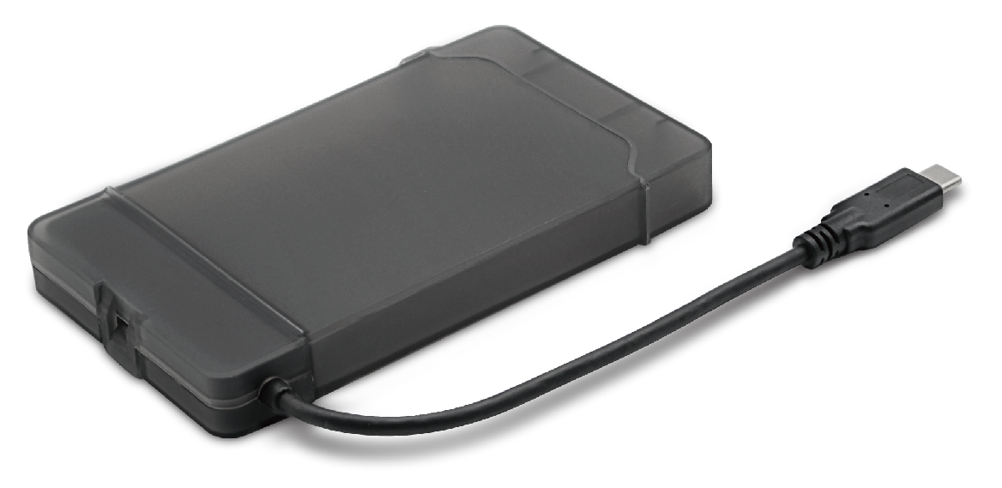

DESCRIPTION
Are you looking for a high-performance but fully backward compatible external hard disk enclosure for your desktop, notebook or other computing device? Do you need the extra data transfer performance that USB3.1 can give you for streaming movies without buffering or copying large digital images to and from your computer?
The USB3.1-HD-2.5S-M is your ideal desktop, server or media centre storage enclosure. Featuring a SuperSpeed USB3.1 interface which transfers data around x10 quicker than standard USB2.0. And if your computer only has USB2.0 at the moment, no problem, the enclosure is fully backward compatible with USB2.0 if required,.
Easy for anyone to use, simply connect your existing 2.5" SATA interface hard disk, connect up the supplied USB3.1/USB2.0 data cable and start using it in a few minutes.
Fully Plug n' Play with WindowsTM including Windows10TM and Mac OS XTM operating systems.

FEATURES
> Utilize your existing 2.5' Hard Disk or SSD
> Ideal for WindowsTM or MacTM users
> SuperSpeedTM USB3.1 Gen 1- up to 5Gbps
> No drivers needed - just plug and go
> Backward compatible with USB2
> Stylish, passive cooled design

SPECIFICATIONS
